# Chapter 3. Results from the long term Ndep measurements

Data in Griffin have been collected from October 2011 to May 2017. 198 precipitation depths, 233 v-notch flows, 1257 stemflow volumes and 1112 throughfall depths have been collected. 2937 NH4-N and 2943 NO3-N samples have been analysed via colorimetric analysis, including 2 blanks per each monthly batch.

## Corrections to the database

Outliers. The database has been analysed in R to detect possible outliers by using the Tuckey’s method. This procedure allows to highlight possible errors in data collection or copy in field or populating the database. No outliers were found in TF, SF, RF and cloudwater water volumes (2800 data in total).

When applied to the lab results by N species and N source, Tukey’s method alone shows a very high number of potential outliers, due to many reasons:

1. Dates with peaks of Ndep: high levels of Ndep are shown on March-April 2013 and April 2014 and confirmed by other sources (MAXVIENO); in these cases no data have been rejected
2. Data from several samplers of a N flux showed high values compared to the inputs, but this occured in months with low precipitation or relatively low N mass values
3. The variability between samples that can be the result of different variables (water volume, contaminants in the barrels).

A precautional approach aimed to minimise the number of rejected data was adopted and in the following table are shown the outliers accepted and removed from the database:

|  |  |  |
| --- | --- | --- |
| Date | Sample | N form |
| 19/10/2015 | T11T2 | NO3.N |
| 22/08/2013 | T11T2 | NH4.N |
| 21/04/2015 | T12T1 | NH4.N |
| 24/04/2014 | T12T1 | NH4.N |
| 24/07/2014 | T10S2 | NO3.N |
| 24/07/2014 | T10S2 | NH4.N |
| 20/06/2014 | T12S2 | NH4.N |
| 23/02/2015 | T10S1 | NH4.N |
| 28/07/2013 | T10S2 | NH4.N |
| 22/08/2013 | C10S1 | NH4.N |
| 23/02/2015 | T10S2 | NH4.N |
| 26/04/2012 | T10S2 | NH4.N |
| 17/06/2015 | C31D1 | NH4.N |
| 21/07/2015 | C31D1 | NH4.N |
| 03/10/2013 | C31D1 | NH4.N |
| 22/06/2016 | C31D1 | NH4.N |
| 25/07/2016 | C30D1 | NH4.N |

Regression and interpolation. The data from the rainfall gauges and the harp-wire cloudwater collector needed che?

## Precipitation and throughfall

The measured precipitation in Griffin for the period 2012-2016 was 1074 mm y-1 on average, with a minimum recorded depth of 874 mm in 2013 and a maximum of 1176 mm in 2012.

Data presented in fig. xxx show the monthly precipitation and throughfall in Griffin for the period 2012-2016. The values are the results of the mean between the two rainfall collectors and among the throughfall collectors in both the T and C subbasins. 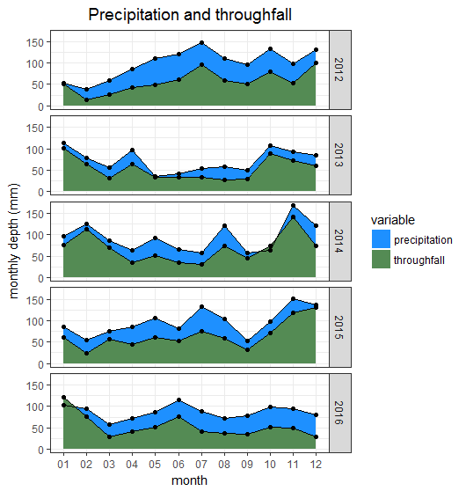

*Fig. xxx: recorded monthly mean precipitation and throughfall at Griffin.*

This data might be underestimating the real precipitation values, as it can be clearly seen in October 2014, December 2015 and January 2016, where TF appears to be higher than the rainfall. As summerised in table xxx, in most cases this anomaly is due to overflowing samplers or in some other cases to the funnels out of the samplers, usually squeezed out by the forzen sample.

|  |  |
| --- | --- |
| Date | Overflowing samplers |
| 24/01/2014 | both |
| 27/02/2014 | both |
| 31/10/2014 | C30D1 |
| 27/11/2014 | both |
| 21/07/2015 | both |
| 20/11/2015 | both |
| 17/12/2015 | both |
| 19/01/2016 | C30D1 |
| 20/02/2016 | C31D1 |
| 22/06/2016 | C30D1 |
| 22/11/2016 | C30D1 |

*Table xxx: precipitation sample overflows*

The ratio between throughfall depth, 67% on average in the period considered, is high if compared to Heal, et al. (2004) where throughfall accounted for about 45% of the precipitation and Ford E. D. (1978) where throughfall counted for the 43% on a precipitation of about 1639 mm y-1 and can only be partly explained by the missing rainfall volumes due to the partial samplings in the overflowing dates.

## Precipitation and throughfall volumes

## Stemflow

Stemflow represents a minimal part of the hydrological balance, about a 1% of the precipitation on average with a peak of 3% in 2016.

Trying to work on DBH^2 ma pare na cacata…

Explanation of how the “average tree” has been calculated. Segui lo script

Analysis by DBH^2: see Heal et al 2004 pg. 485: plot

Methodology: gauged flow by bucket! Comparison?

Notes for later:

Mitchell work with 87-93 of CNU!

Results for the 5 years dataset: Descrizione del database ottenuto -> fieldwork and lab methodology, data quality (NAs), data treatment, outliers, regression and interpolation.

References

1. Heal, K.V., Stidson, R.T., Dickey, C.A., Cape, J.N. and Heal, M.R. 2004 New data for water losses from mature Sitka spruce plantations in temperate upland catchments. *Hydrolog Sci J*, **49** (3), 477-493.

2. Ford E. D., D.J.D. 1978 The Effects of Canopy Structure on Stemflow, Throughfall and Interception Loss in a Young Sitka Spruce Plantation. *Journal of Applied Ecology*, **15** (3), 905-917.